YEAR 12 CHEMISTRY - 3ACHE

TEST 3 - 2013

Acids and Bases

/55
Recommended time: 1 hour

Name: _____________________________________________________

Teacher: _____________________________________________________

This test is in two parts.

Part 1: Multiple choice style test consisting of (15) questions.
Each question is worth 1 mark.
Write your answers in the table provided.
Attempt ALL Questions

Part 2: Short and/or Extended Answer questions
Write all answers in the spaces provided.
The marks allocated to each question are shown at the foot of each question.

PART 1: MULTIPLE CHOICE (15 marks)

Answer ALL questions in Part 1 on the Separate Multiple Choice Answer Sheet provided.
Each question in this part is worth 2 marks. This part carries 15 marks.

- Which of the following possibilities describes the pH of a solution of the following compounds dissolved in distilled water?

 | Ammonium  Nitrate | Potassium  Carbonate | Sodium  Chloride | Calcium  Oxide
a) | Less than 7 | Greater than 7 | Equals 7 | Greater than 7
b) | Less than 7 | Equals 7 | Less than 7 | Greater than 7
c) | Less than 7 | Equals 7 | Less than 7 | Equals 7
d) | Equals 7 | Greater than 7 | Equals 7 | Greater than 7

- In which of the following reactions is water acting as an acid?

  - Fe³⁺(aq) + 6 H₂O(l) → Fe(H₂O)₆³⁺(aq)
  - H₂SO₄(l) + H₂O(l) → HSO₄―(aq) + OH―(aq)
  - NH₃(g) + H₂O(l) → NH₄⁺(aq) + OH―(aq)
  - NaOH(s) + 4 H₂O(l) → Na(H₂O)₄⁺ + OH―(aq)

- Consider the following reaction :

HCN(aq) + NH₃(aq) ⇄CN―(aq) + NH₄⁺(aq)

Which of the species in this equilibrium mixture are acting as bases?

  - HCN(aq) and NH₄⁺(aq)
  - NH₃(aq) and CN―(aq)
  - HCN(aq) and CN―(aq)
  - NH₃(aq) and NH₄⁺(aq)

- The pH of an aqueous solution registers 11.0 on a pH meter. Which of the following solutions could be its identity?

  - 0.0010 molL⁻¹KOH
  - 0.0100 molL⁻¹NaOH
  - 0.0010 molL⁻¹HCl
  - 0.0050 molL⁻¹Ca(OH)₂

- Which of the following oxides dissolves in water to give the most strongly basic solution?

  - sulfur trioxide
  - sodium oxide
  - aluminium oxide
  - barium oxide

- Solid sodium hydrogen carbonate is added to deionised water at pH 7.00. Which of the following statements explains what then occurs?

  - The pH decreases due to a reaction between HCO₃⁻ ions with water.
  - The pH decreases due to a reaction between Na⁺ ions with water.
  - The pH increases due to a reaction between HCO₃⁻ ions with water.
  - The pH increases due to a reaction between Na⁺ ions with water.

- A 0.200 molL⁻¹ oxalic acid solution (H₂C₂O₄) is just 2.5% ionized in terms of one of its ionisable hydrogen atoms. You need not consider the second available ionization in this situation. What is the pH of the solution?

  - 0.50
  - 1.15
  - 3.20
  - 2.30

- Which of the following best describes a weak acid?

  - A weak acid has [H⁺] less than 10⁻³molL⁻¹.
  - A weak acid is a concentrated acid that has been diluted.
  - A weak acid has more of its own molecules than ions in solution.
  - A weak acid is used as a buffer, strong acids cannot be used.

- A 0.1 molL⁻¹ HNO₃ solution has [H⁺] = 0.1 molL⁻¹, whereas a 0.1 molL⁻¹ CH₃COOH solution has [H⁺] = 0.003 molL⁻¹. The best explanation for this difference is that:

  - CH₃COOH molecules ionizes more than HNO₃ molecules.
  - HNO₃ is an ionic substance whereas CH₃COOH is molecular covalent.
  - Each HNO₃ molecules ionize completely, but each CH₃COOH only partially ionizes.
  - HNO₃ donates protons to form H₃O⁺(aq) in water more readily than CH₃COOH does.

- When the indicator Cresyl Blue is used it shows these results for high pH solutions :

pH | Colour with Cresyl Blue
10.0 | Blue
11.0 | Green
12.0 | Yellow
13.0 | Yellow

When 2 unknown solutions are tested with Cresyl Blue they give the
following results:

Unknown solution | Colour with Cresyl Blue
X | Yellow
Y | Blue

Which of the following statements are supported by these observations?

  - The pH of X is 12.0, and the pH of Y is 10.
  - The pH of X is between 12.0 and 13.0, and the pH of Y is 10.
  - The pH of X is between 12.0 and 13.0, and the pH of Y is 10 or less.
  - The pH of X is 12.0 or more, and the pH of Y is 10 or less.

- Pyrophosphoric acid, H₄P₂O₇, is a tetraprotic acid. The most likely structure of this acid’s molecule is

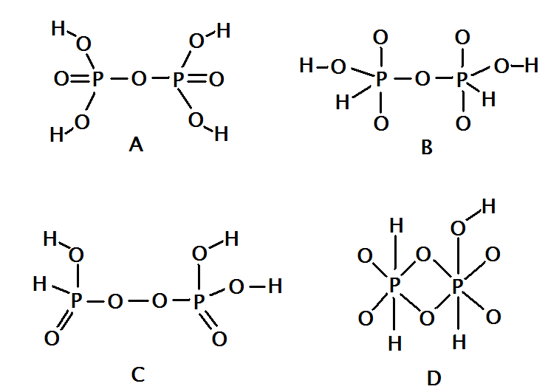

  - A
  - B
  - C
  - D

12.When the pH of a 0.01 mol L⁻¹ solution of sulfuric acid is measured it is found to be significantly lower than the pH of a 0.01 mol L⁻¹ solution of phosphoric acid. What is the reason for this?

- Phosphoric acid is a triprotic acid, while sulfuric acid is only diprotic, therefore the concentration of hydrogen ions is higher in the phosphoric acid solution than in the sulfuric acid solution.
- Phosphoric acid is a stronger acid than the sulfuric acid, so the phosphoric acid is more likely to produce hydrogen ions in solution than the sulfuric acid.
- Sulfuric acid is a stronger acid than phosphoric acid, so there are more hydrogen ions in the sulfuric acid solution than the phosphoric acid solution.
- The sulfuric acid solution is more concentrated than the phosphoric acid solution, therefore there will be more hydrogen ions in the sulfuric acid solution than the phosphoric acid solution.

13.Pure water undergoes self-ionisation according to the equation:

2H₂O(l)H₃O⁺(aq) + OH⁻(aq)

The equilibrium constant for the reaction changes with temperature:

Temperature ºC | K _{water}
25ºC | 1.0 x 10⁻¹⁴
100ºC | 5.5 x 10⁻¹³

Which one of the following statements is correct?

- At 100ºC the pH of water is less than 7, but the water is still neutral.
- At 100ºC the pH of water is less than 7, and therefore the water is acidic.
- At 100ºC the pH of pure water is greater than 7.0, and therefore the water is
basic.
- At 100ºC the pH of water is greater than 7, and therefore the water is acidic.

14. Which of the following solutions has the highest pH?

- 1.0 mol L⁻¹ sodium chloride.
- 2.0 mol L⁻¹ hydrochloric acid
- 1.0 mol L⁻¹. ammonia solution.
- 1.0 mol L⁻¹ sodium hydroxide.

15. A student requires a solution of pH = 4 for an experiment.
Which of the following procedures will yield such a solution?

- Add 50 mL of a solution of pH = 2 to 50 mL of a solution of pH = 6.
- Ad 1.0 mL of 0.01 mol L⁻¹ HCl (aq) to 99 mL of distilled water.
- Add 50 mL of 0.1 mol L⁻¹ NaOH to 25 mL of 0.1 mol L⁻¹ KOH (aq).
- Add 95 mL of distilled water to 5 mL of 0.1 mol L⁻¹HCl (aq).

END OF MULTIPLE CHOICE QUESTIONS

Year 12 Chemistry Test 3

Multiple-Choice and Short Answer Booklet

Total 55 marks

Name: _____________________________

Teacher: _____________________________

For each question, shade the box to indicate your answer.
Use only a blue or black pen to shade the boxes.

For example, if b is your answer: a  b  c  d 

If you make a mistake, place a cross through that square then shade your answer.
Do not erase or use correction fluid.

For example, if b is a mistake and d is your correct answer: a  b  c  d 

If you then want to use your first answer b, cross out d and then circle b.

a b  c  d 
Marks will not be deducted for incorrect answers.
No marks will be given if more than one answer is completed for any question.

PART 1:
Questions 1-15

1 | a b  c  d  |  | 9 | a b  c  d 
2 | a b  c  d  |  | 10 | a b  c  d 
3 | a b  c  d  |  | 11 | a b  c  d 
4 | a b  c  d  |  | 12 | a b  c  d 
5 | a b  c  d  |  | 13 | a b  c  d 
6 | a b  c  d  |  | 14 | a b  c  d 
7 | a b  c  d  |  | 15 | a b  c  d 
8 | a b  c  d 
(15 marks)

PART 2: WRITTEN SECTION (25 marks)

This section has five short answer type questions. Write your answers using blue or black pen in the spaces provided. This part is worth a total of 25 marks.

1. Write balanced ionic equations and give observations for the reactions that occur between the following reactants. Also write the observation that would occur as the reaction proceeded. [Total 9 marks]

(a) Cobalt (II) hydroxide solid is added to 1 mol L⁻¹ Hydrochloric acid solution.

Equation:
________________________________________________________[ 2 marks]

Observation: [1 mark]

(b) Nitric Acid solution is added to solid calcium hydroxide powder.

Equation:
_______________________________________________ [ 2 marks]

Observation: [1 mark]

(c) Oxalic acid acid crystals, H₂C₂O₄ (you may consider them anhydrous for this equation), are added to a solution of universal indicator in neutral water. Show the dissociation equation of just one hydrogen ion per molecule.

Equation:
________________________________________________[ 2 marks]

Observation: [1 mark]

2. Five clear solutions, whose formulas are shown below, are to be identified by carrying out the testing shown in the FLOW CHART below. Write the formulas of the substances that would be recorded in the empty boxes so that finally all 5 would be identified.
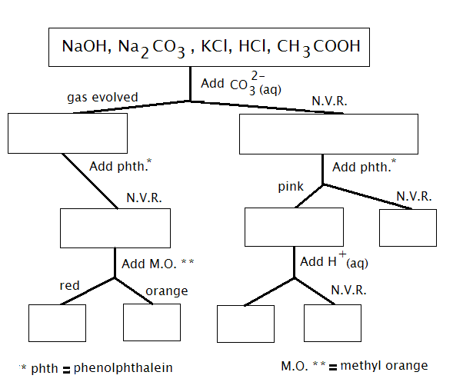
[6 marks]

Add red litmus paper
Add red litmus paper
Add universal indicator
Blue

3. When 0.020 moles of barium hydroxide solid is added to 800 ml of 0.010mol L⁻¹ NaOH eventually a clear solution is formed.

a) Calculate the final OH⁻ (aq) concentration.

[3 marks]

b) Calculate the final pH of the mixture, assume the final volume remains at 800 ml.

[2 marks]

4. If 125 ml of HCl having pH of 2.0 is added to 540 ml of HNO₃ of pH 3.0. Calculate the pH of the final solution.
[5 marks]

Part 3.PRACTICAL TEST: pH OF SALT SOLUTIONS

In experiment 10, you tested the pH of a number of salts.
Using your understanding gained from conducting this experiment, complete the following table:

Complete the following table.[15 marks]

Solute  (0.1 mol L⁻¹) | Colour of Universal Indicator | pH of solution  ( < 7, = 7 or > 7 ) | Explanation  (Write an equation when appropriate)
Potassium
nitrate

Ammonium
chloride

Sodium
carbonate

Sodium acetate
[NaCH₃COO]

Sodium Hydrogen
Carbonate

END OF TEST

